Lithics Exercise An 3571 Anthropological Archaeology Prof. Spencer-Wood

Marcus Dennehy

| Stone # | Typology | Dimensions(cm) | Size | Manufacture type |
| --- | --- | --- | --- | --- |
| 1 | Core, novaculite, core, possible anvil | Length:16 cm  Width: 12.9 cm  Thickness: 8 cm | Large | A |
| 2 | Blade, chert, red contains red cortex with cryptocrystalline pieces poking out. Pressure flaking. | Length: 7.2 cm  Width: 5.2 cm  Thickness: 0.5 cm | Large | B |
| 3 | Novaculite core shaped into an arrow head. Dull brown to gray color. Punch technique | Length: 7.8 cm  Width: 4.4 cm  Thickness: 2 cm | Large | A |
| 4 | Stone:Chert  Color: Grey to light red  Type: Hard hammer percussion  Bifacial | Length: 6.3 cm  Width: 5.5 cm  Thickness: 0.95 cm | Large | A |
| 5 | Stone: Quartzite cobble  Color: Tan brown to gray  Type: Hard hammer, possible scraper | Length: 7.6 cm  Width: 5.3 cm  Thickness: 2.5 cm | Large | C |
| 6 | Stone: Chert  Color: Light to dark red  Type: Pressure flaking / soft hammer  bi facial | Length: 3.2 cm  Width: 2.5 cm  Thickness: 0.2 cm | Small | C |
| 7 | Stone: Obsidian  Color: Pure abyssal black  Type: Soft hammer  Unifacial | Length: 1.7 cm  Width: 2.5 cm  Thickness: 0.6 cm | Small | B |
| 8 | Stone: Chert  Color: Brown to dark red  Type: Soft hammer  Bi facial | Length: 3.9 cm  Width: 3.4 cm  Thickness: 0.4 cm | Small | B |
| 9 | Stone: Chert  Color: Maroon to dark purple  Type: Soft hammer/pressure flaking  Bi facial | Length: 2.5 cm  Width: 3 cm  Thickness: 0.15 cm | Small | C |
| 10 | Stone: Chert  Color: Gray to black  Type: Soft hammer/pressure flaking  Bi facial | Length: 4.4 cm  Width: 4.4 cm  Thickness: 0.3 cm | Small/medium | C |
| 11 | Stone: Chert  Color: Red to dark purple  Type: Pressure flaking  Bi facial | Length: 3.4 cm  Width: 2.4 cm  Thickness: 0.10 cm | Small | C |
| 12 | Stone:Novaculite  Color: Dull gray  Type: Pressure flaking  Bi facial | Length: 3.9 cm  Width: 1.7 cm  Thickness: 0.2 cm | Small | C |
| 13 | Stone: Chert core  Color: Dark red  Type: Soft hammer  Unifacial | Length: 3.1 cm  Width: 4.5 cm  Thickness: 0.5 cm | Small | C |
| 14 | Stone:Chert  Color: Dark red  Type: Soft hammer | Length: 2.9 cm  Width: 3.1 cm  Thickness: 0.55 cm | Small | C |
| 15 | Stone: Chert  Color: White light gray  Type: Soft hammer percussion | Length: 3.5 cm  Width: 3.9 cm  Thickness: 0.25 cm | Small | C |
| 16 | Stone: Flint  Color: Clear brown to tan  Type: Blade, pressure flaking | Length: 4.4 cm  Width: 2.9 cm  Thickness: 0.2 cm | Small | C |
| 17 | Stone:Chert  Color: Pale pink to white  Type: Soft hammer percussion | Length: 4.1 cm  Width: 3.3 cm  Thickness: 0.2 cm | Small | C |
| 18 | Stone: Obsidian  Color: Black  Type: Cortex | Length: 7.4 cm  Width: 6.5 cm  Thickness: 3.25 cm | Large | A |
| 19 | Stone: Obsidian  Color: Black  Type: Pressuring flaking | Length: 12.3 cm  Width: 9 cm  Thickness: 1.65 cm | Large | C |
| 20 | Stone: Chert  Color: Red tinged to orange  Type: Soft hammer, pressure flaking | Length: 10.1 cm  Width: 6.5 cm  Thickness: 0.45 cm | Large | B |
| 21 | Stone:Chert  Color: Dark brown to purple  Type: Punch technique | Length: 4.9 cm  Width: 2.6  Thickness: 0.8 cm | Medium | B |
| 22 | Stone: Flint  Color: Black  Type: Pressure flaking  Finished Product | Length: 6 cm  Width: 3.5 cm  Thickness: 0.55 cm | Medium | C |
| 23 | Stone: Chert  Color: Pale gray  Type: Soft hammer percussion | Length: 5.5 cm  Width: 5 cm  Thickness: 0.75 cm | Medium | B |
| 24 | Stone: Chert  Color: Pale red  Type: Punched, pressure flaking | Length: 3.9 cm  Width: 5 cm  Thickness: 0.5 cm | Medium | B |
| 25 | Stone: Chert  Color: Tri color, red, white, gray  Type: Soft hammer percussion | Length: 5.8 cm  Width: 3.7 cm  Thickness: 0.45 cm | Medium | B |
| 26 | Stone: Chert  Color: Light to dark brown  Type: Pressure flaking, soft hammer | Length: 4.4 cm  Width: 5.7 cm  Thickness: 0.65 cm | Medium/large | B |
| 27 | Stone: Novaculite  Color: Sandy brown  Type: Finished arrowhead | Length: 4.5 cm  Width: 3 cm  Thickness: 0.2 cm | Medium | C |
| 28 | Stone: Chert  Color: Gray  Type: Finished Scraper, pressure flaking | Length: 5.3 cm  Width: 4 cm  Thickness: 0.85 cm | Medium | C |
| 29 | Stone: Chert  Color: Pink red  Type: Soft hammer, pressure flaking | Length: 6 cm  Width: 4.5 cm  Thickness: 0.5 cm | Medium/large | B/Or C* |
| 30 | Stone: Chert  Color: Medium brown  Type: Soft hammer percussion | Length: 4.5 cm  Width: 3.9 cm  Thickness: 0.35 cm | Medium | B |
| 31 | Stone: Novaculite  Color: Gray  Type: Pressure flaking | Length: 5 cm  Width: 2.8 cm  Thickness: 0.6 cm | Medium | B-C |
| 32 | Stone: Novaculite  Color: Gray  Type: Soft hammer percussion | Length: 5.3 cm  Width: 2.1 cm  Thickness: 0.70 cm | Medium | B-C |
| 33 | Stone: Novaculite  Color: White to gray  Type: Soft hammer percussion | Length: 4.2 cm  Width: 4.3 cm  Thickness: 0.65 cm | Medium | B |
| 34 | Stone: Chert  Color: Tri color  Type: Soft hammer percussion | Length: 5.4 cm  Width: 2.5 cm  Thickness: 0.80 cm | Medium/small | B-C |

Litchis Exercise Report:

After analyzing, gathering and typing the stone tools, we can infer a lot about the 3 stages of stone age tool making on this specific site. Flakes of many stages of production were found. From unfinished cores, to meticulously flaked arrowheads and hand axes, there have been a numerous amount of identifiable manufactured stone tools. All from the early phases to the finishing touches.

The most prominent stage of production at this specific site were mostly medium size pieces, in between stage B and C of their production. But for a multitude of reasons, it did not finish production. The term production does not exactly fit each and every stone. Crafting these stones took hours, so these stones might have been made by individual people, instead of a "production line". Instead, the person would have "production stages" that culminate into the full craft of the tool. However, data collected analyzing the stone tools dimensions from the site suggest that there was a definitive way or method of crafting certain tools.

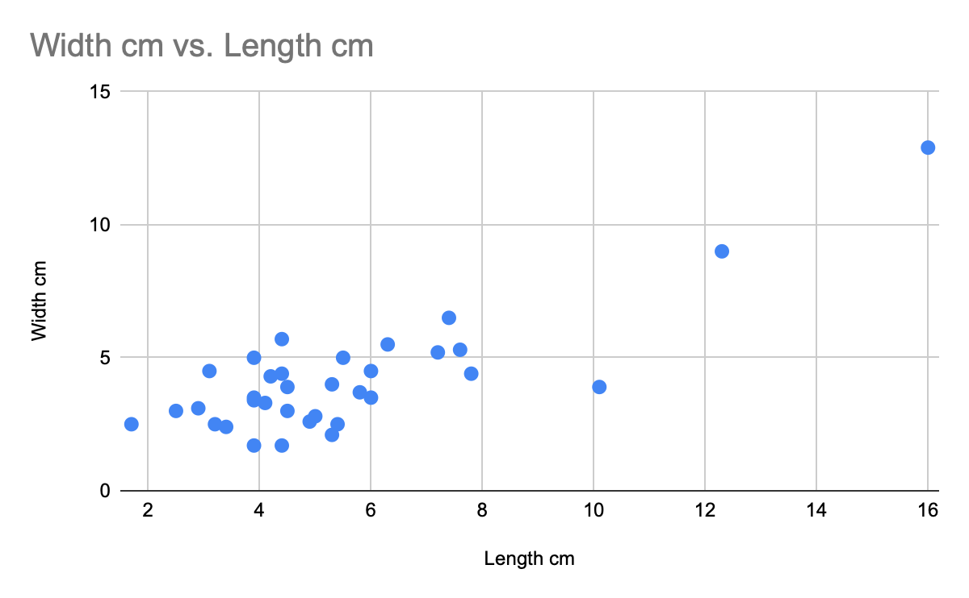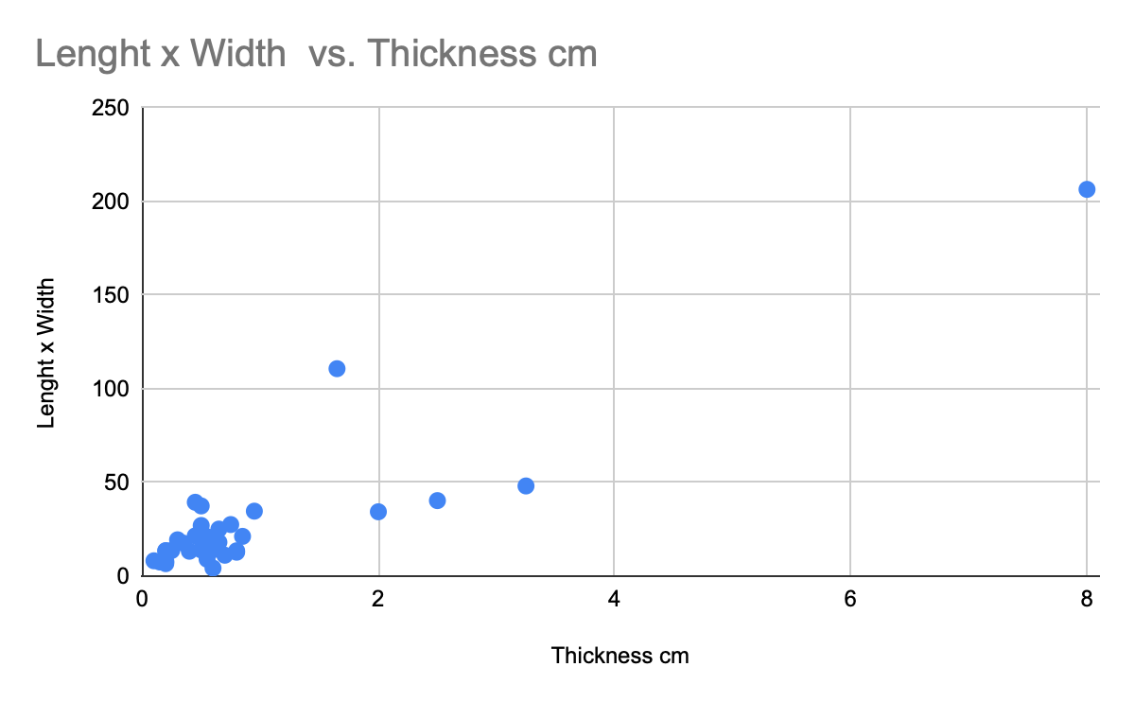

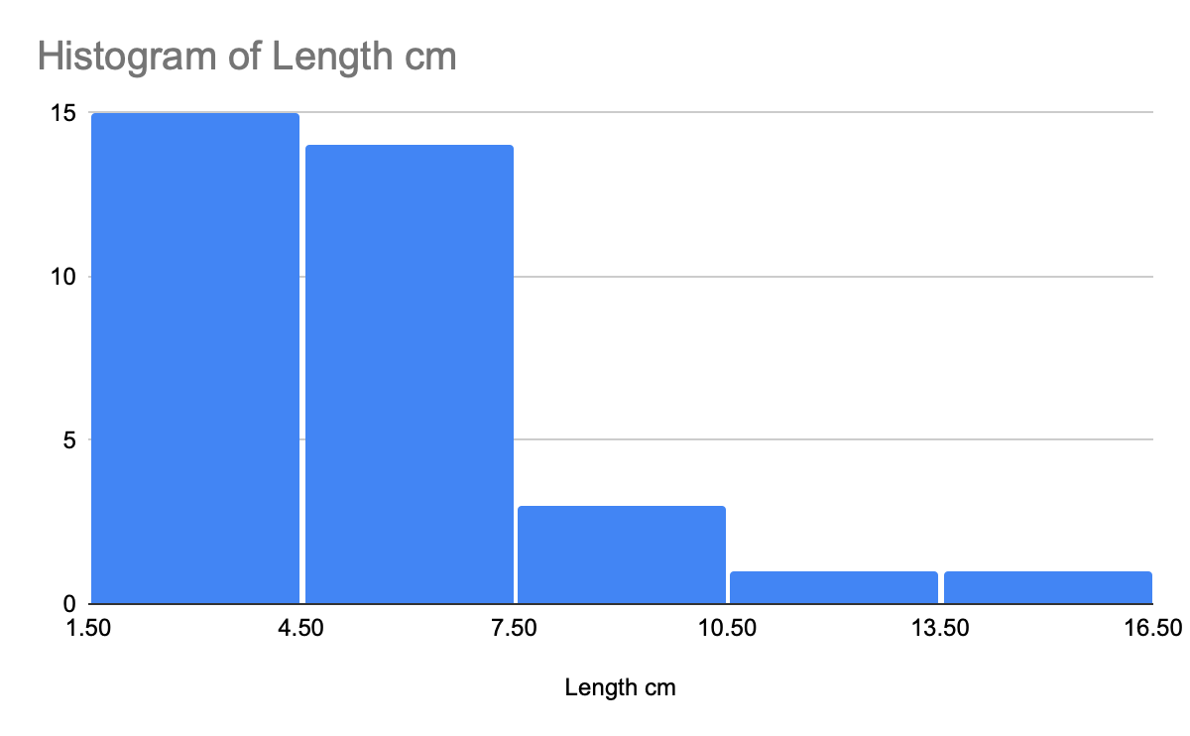

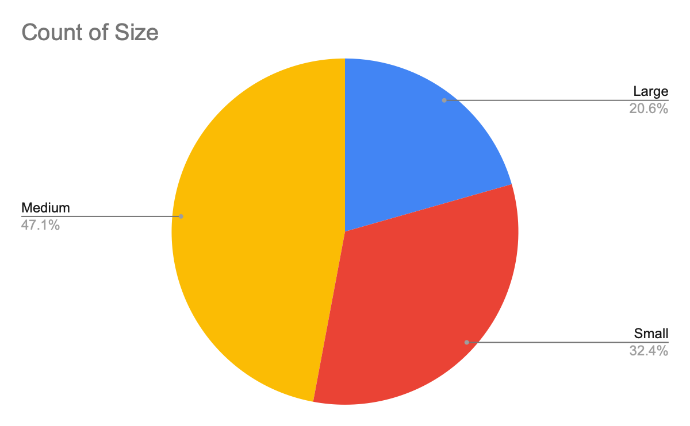

(All graphs will be numbered top to bottom, 1: Width VS Length[Scatterplot] 2: Length x Width VS Thickness [Scatterplot] 3: Length of Stone Tools [Histogram] 4: Percentage of Size [Pie Chart])

The data suggests many things on the fundamental 3 phases of tool making. In terms of the 3 stages, most of these stone tools are "discontinued" in stage B. Many of these stone flakes have cores that make it very difficult for soft/hard hammer percussion, making many of them hard to pressure flake, because of how solid the cores are. The amount of these suggest a number of things, a) The amount of these flakes are waste/debitage b) they were trashed during their production process because of their flaws.

Now considering the statistically insignificant, we can infer the cultural significance by looking at the smaller and larger stone tools. Also, looking at the couple of finished tools that indicate what type of things people were doing at this site. Stone tools 22, 27 and 28 all seem to be fully, if not completely finished. Stone tool 22 being an english flint arrowhead, the flint being pitch black, almost obsidian like. Unlike obsidian, the flint flaked off in predictable ways and formed this hunting arrowhead. 27, being another arrowhead made of novaculite, and a bit less refined than 22. However, this arrowhead tool has two notches jutting out on its side. This leads me to believe that spears as well as hand axes were in operation at this site. This infers a type of hunting site, where game would be hunted and then skinned. More evidence of this is seen in stone tool 28, a unifacial tool with a napped surface at the edge, and a semi-curvature shape laying flat. This tool was a scraper, used for skinning animal pelts with its sharp end and its distinct unifacial base, allowing people to cut under the skin of an animal's pelt.

The variety of these flakes suggest that this was more of a hunting site than a quarry. Firstly, the diversity of stone here, novaculite, obsidian, different kinds of flint from across the ocean, as well as many kinds of chert. If this were a quarry, it would have shown many different things being produced, such as agricultural tools or landscaping stone tools. The fact that there were many unfinished blades also suggests that people brought these stones from quarries miles away, trying to form them into blades or handaxes at the site. It would also be effective for the hunters to have a variety of stones to use, because certain animals require specialized tools in order to take them down.

To conclude, I made a chart comparing different types of stones, comparing them to the scatterplot data seen above.

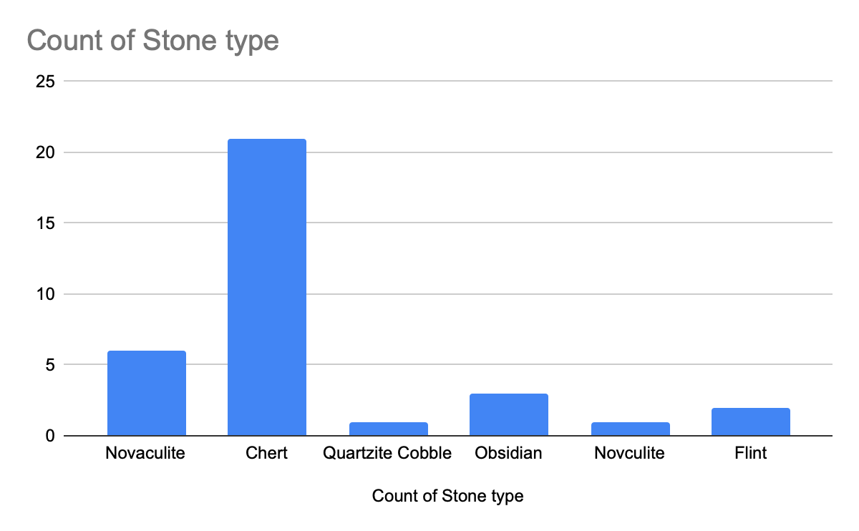

This bar graph can show a variety of different stories at this site. Although many of them seem to be chert, that might be only because a lot of chert was debited, a lot of the finished tools ended up being obsidian, novaculite, or flint. This makes me suspect the scatterplot data shows stranglers far away from the cluster. This suggests the specialization some stones had compared to others. Stones like obsidian can be used from a numerous amount of things, cortices, blades and attempted shaped arrowheads have all been seen at this site made out of obsidian.

This bar graph tells us that even though we feel like we have taken every look at every angle at something, some things pop up unexpectedly to stir the pot. This graph also tells us a different story of what type of stone tools might have been used at this site.

